|  |  |
| --- | --- |
| **WEBSITE DESIGN WITH JQUERY ACTIONS** | **Ex. No: 7** |
| **07/09/2023** |

# Aim

# To create web page using HTML, CSS, JQuery actions.

# Description

jQuery actions encompass the dynamic and interactive features that can be seamlessly integrated into web pages through the jQuery JavaScript library. With jQuery, developers can streamline the process of selecting HTML elements and applying various actions, transforming static websites into engaging and user-friendly experiences.

These actions often revolve around responding to user interactions. For instance, jQuery allows developers to detect and respond to events like clicks, mouse hover, and keyboard input, enabling the creation of responsive and interactive web interfaces. jQuery also facilitates smooth animations, such as fading elements in and out, sliding content, and transitioning between different styles, adding visual appeal to web applications.

Furthermore, jQuery's AJAX capabilities empower websites to fetch and update data from servers without requiring a full page refresh. This feature enables dynamic content loading, making web applications more efficient and user-centric.

In essence, jQuery actions serve as a powerful toolkit for enhancing web development, simplifying complex tasks, and delivering captivating user experiences, making it a staple for web developers seeking to create interactive and feature-rich websites.

Fade In:

To make an element gradually appear (fade in), you can use the fadeIn() method. Here's the syntax:

$(selector).fadeIn(speed, callback);

Fade Out:

To make an element gradually disappear (fade out), you can use the fadeOut() method. The syntax is similar:

$(selector).fadeOut(speed, callback);

Toggle Fade:

You can also toggle between fading in and fading out with the fadeToggle() method:

$(selector).fadeToggle(speed, callback);

These jQuery methods provide a simple way to add smooth fade effects to elements on your web page, improving the user experience and visual appeal of your site.

**Program**

<!DOCTYPE html>

<html lang="en">

<head>

<meta charset="UTF-8">

<meta name="viewport" content="width=device-width, initial-scale=1.0">

<title>cake shop</title>

<script src="https://ajax.googleapis.com/ajax/libs/jquery/3.6.4/jquery.min.js"></script>

<script >

$(document).ready(function(){

$('#btn').click(function(){

var n=parseInt($('#c1').val());

var cake1=n*300;

var a=parseInt($('#c2').val());

var cake2=a*300;

var b=parseInt($('#c3').val());

var cake3=b*300;

var i=parseInt($('#c4').val());

var cake4=i*300;

var order=cake1 + cake2 + cake3 + cake4;

$('#o1').val("Rs."+ order);

})

})

</script>

<style>

*{

margin:0px;

}

h1{

background-color:rgb(238, 98, 17);

color:white;

}

.b5{

word-spacing:300px;

}

.order{

color:rgb(69, 77, 143);

font-weight: bold;

padding-left: 500px;

}

#c1,#c2,#c3,#c4{

width: 550px;

border-width: 3px;

height: 30px;

border-radius: 5px;

}

#btn{

background-color: rgb(17, 215, 230);

border-radius: 5px;

}

</style>

</head>

<body>

<h1><center>CAKE SHOP</center></h1>

<div>

<img src="https://www.theflowerspoint.com/data/cache/images/cakes/rainbow-cake/rainbow-round-cake-441x441.jpg" width="400px" height="280px">

<img src="https://www.fnp.com/images/pr/l/v20221205202745/chocolate-rose-designer-cake-1-kg_1.jpg" width="380px" height="280px">

<img src="https://faridabadcake.com/wp-content/uploads/2023/03/luscious-choco-vanilla-cake.jpg" width="380px" height="280px">

<img src="https://www.cakehut.in/image/cache/catalog/2021%20cake%20photos/Double%20Chocolatee-600x600w.jpg.webp" width="340px" height="280px">

</div>

<div class="b1"></div>

<div class="b2"></div>

<div class="b3"></div>

<div class="b4"></div>

<div class="b5">

<label><b>Rainbow-Cake-Rs.300</b></label>

<label><b>Brown-Cake-Rs.300</b></label>

<label><b>White-Cake-Rs.300</b></label>

<label><b>Black-Cake-Rs.300</b></label>

</div>

<br>

<br>

<center><h2>ORDER CAKE</h2></center>

<div class="order">

<br>

<label>Rainbow cake[Quantity]</label>

<br>

<input type="text" id="c1" >

<br>

<br>

<label>Brown cake[Quantity]</label>

<br>

<input type="text" id="c2">

<br>

<br>

<label>White cake[Quantity]</label>

<br>

<input type="text" id="c3">

<br>

<br>

<label>Black cake[Quantity]</label>

<br>

<input type="text" id="c4">

<br>

<br>

<button id="btn" >ORDER</button>

<br>

<br>

<label>TOTAL BILL:</label> <input type="text" id="o1">

</div>

</body>

</html>

**Output**

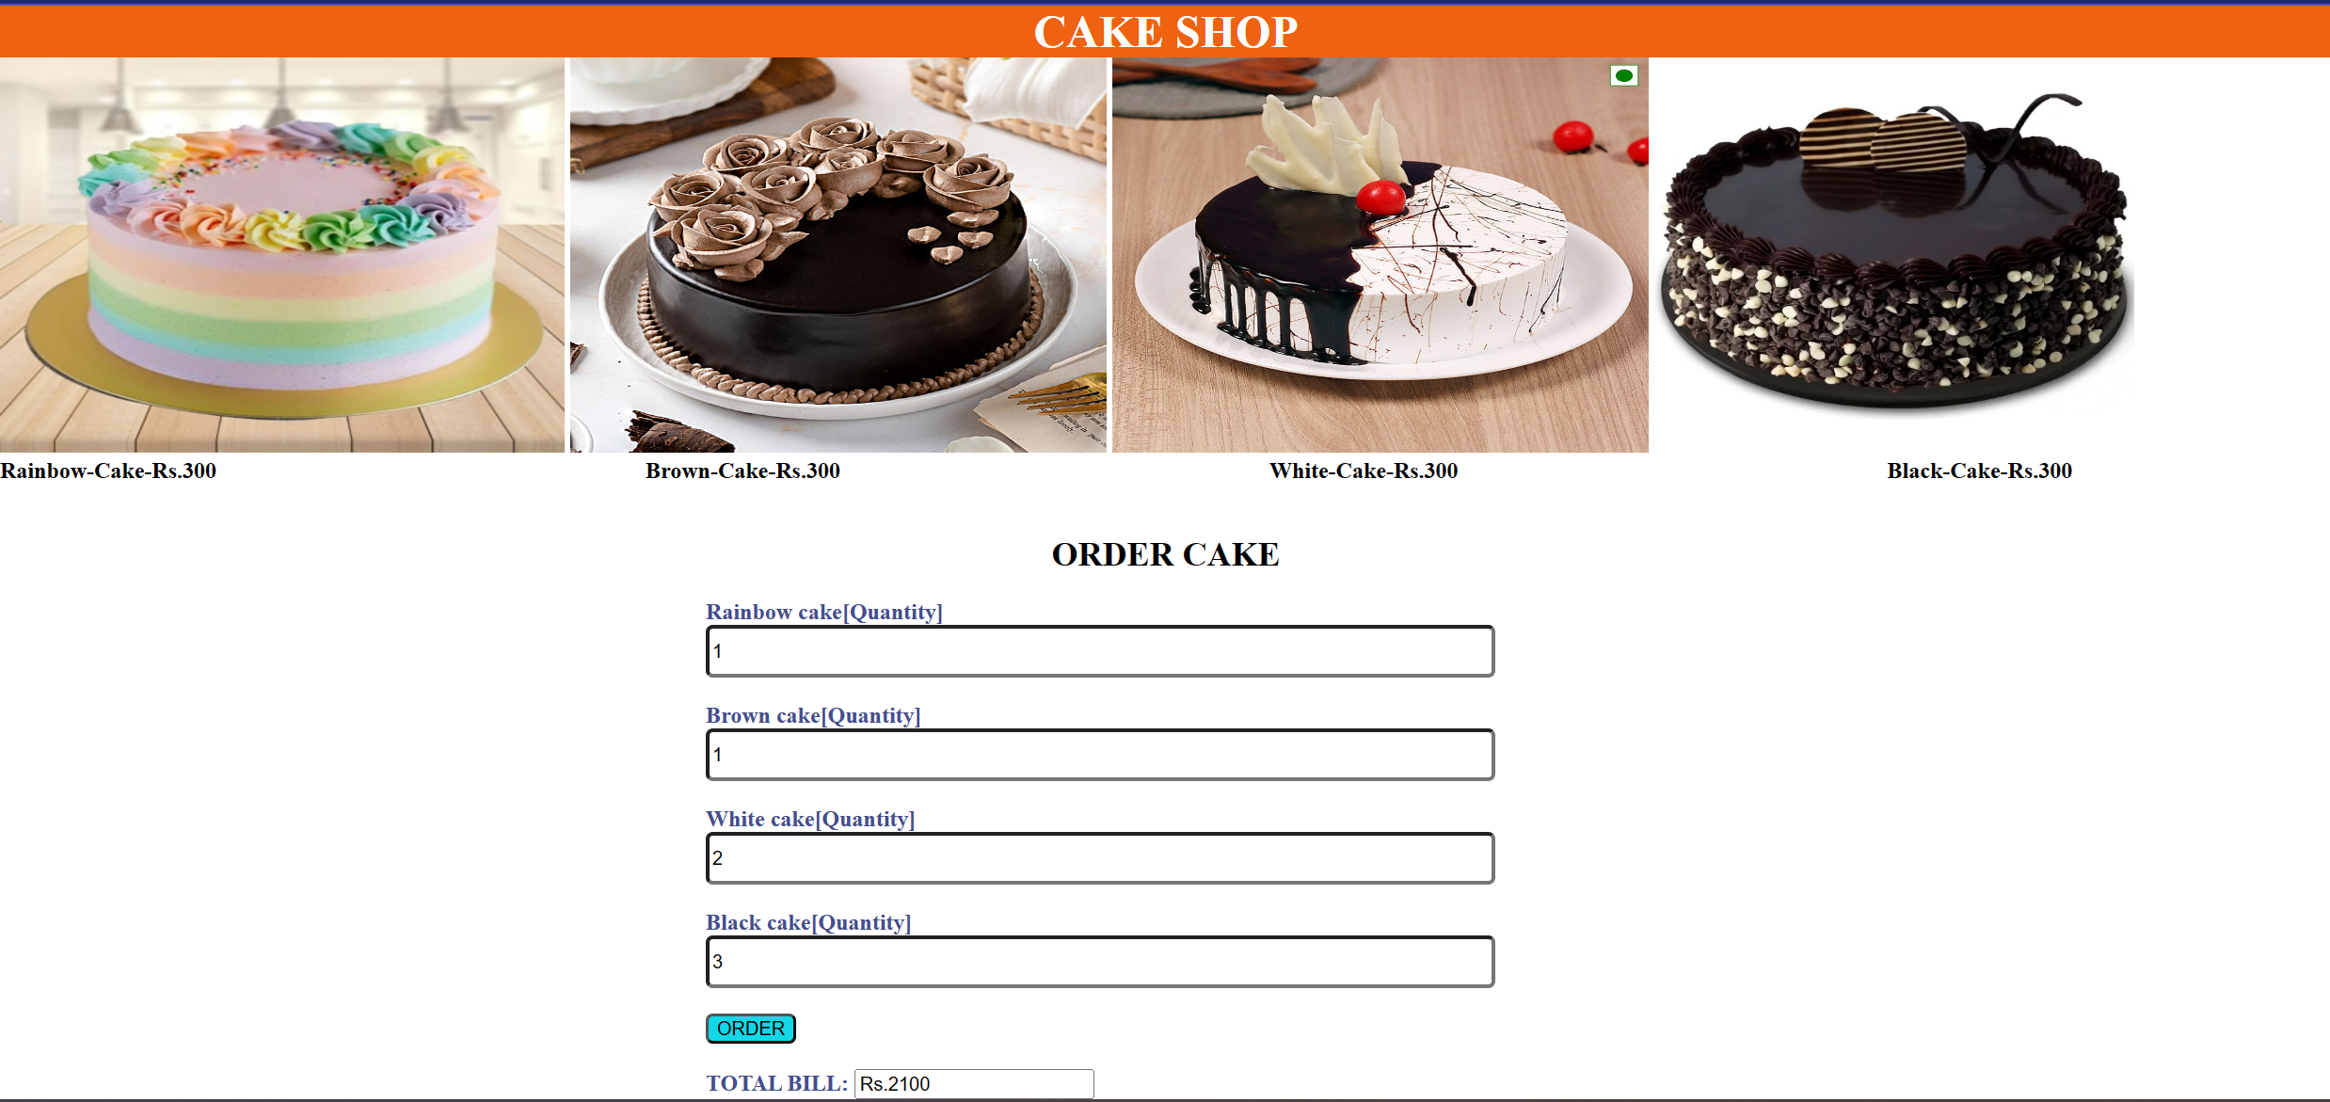

**Question2**

**HTML File:**

<!DOCTYPE html>

<html>

<head>

<title>Question 2 Experiment 7</title>

<script src="https://ajax.googleapis.com/ajax/libs/jquery/3.5.1/jquery.min.js"></script>

<link href="https://cdn.jsdelivr.net/npm/bootstrap@5.3.1/dist/css/bootstrap.min.css" rel="stylesheet">

<script src="https://cdn.jsdelivr.net/npm/bootstrap@5.3.1/dist/js/bootstrap.bundle.min.js"></script>

<style>

.box {

width: 100px;

height: 100px;

background-color: red;

margin: 10px;

border: 2px solid black;

border-radius: 20px;

}

.container {

display: flex;

}

button{

margin-left: 5px;

margin-top: 140px;

}

</style>

</head>

<body>

<h1>Customizer</h1>

<div class="container">

<div class="box"></div>

<div class="box"></div>

<div class="box"></div>

<div class="box"></div>

</div>

<button class="btn btn-primary" id="cssBtn">Change CSS</button>

<button class="btn btn-primary" id="showBtn">Show</button>

<button class="btn btn-primary" id="hideBtn">Hide</button>

<button class="btn btn-primary" id="toggleBtn">Toggle</button>

<button class="btn btn-primary" id="fadeinBtn">Fade In</button>

<button class="btn btn-primary" id="fadeoutBtn">Fade Out</button>

<button class="btn btn-primary" id="fadeToggleBtn">Fade Toggle</button>

<button class="btn btn-primary" id="slideUpBtn">Slide Up</button>

<button class="btn btn-primary" id="slideDownBtn">Slide Down</button>

<button class="btn btn-primary" id="slideToggleBtn">Slide Toggle</button>

<button class="btn btn-primary" id="animateBtn">Animate</button>

<script>

$(document).ready(function() {

var colors = ["violet", "yellow", "blue"];

var currentColorIndex = 0;

$("#cssBtn").click(function() {

$(".box").css("background-color", colors[currentColorIndex]);

currentColorIndex = (currentColorIndex + 1) % colors.length;

});

$("#showBtn").click(function() {

$(".box").show();

});

$("#hideBtn").click(function() {

$(".box").hide();

});

$("#toggleBtn").click(function() {

$(".box").toggle();

});

$("#fadeinBtn").click(function() {

$(".box").fadeIn();

});

$("#fadeoutBtn").click(function() {

$(".box").fadeOut();

});

$("#fadeToggleBtn").click(function() {

$(".box").fadeToggle();

});

$("#slideUpBtn").click(function() {

$(".box").slideUp();

});

$("#slideDownBtn").click(function() {

$(".box").slideDown();

});

$("#slideToggleBtn").click(function() {

$(".box").slideToggle();

});

$("#animateBtn").click(function() {

$(".box").animate({padding: '+=50px'}, 2000);

});

});

</script>

</body>

</html>

**OUTPUT**

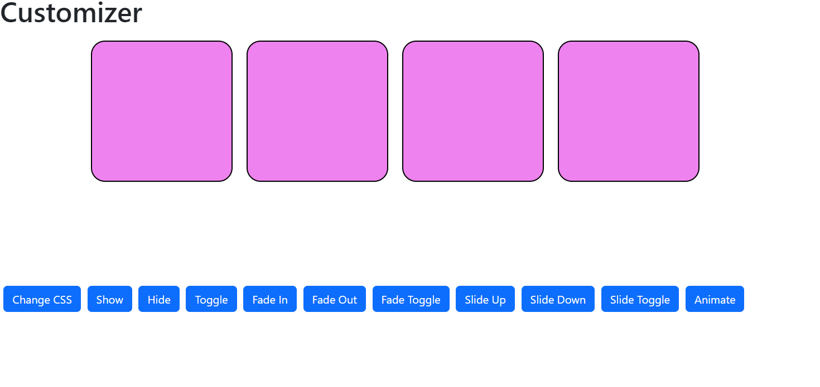

**Result**

Thus, a web page using HTML, CSS, JQuery actions has been created and verified successfully.